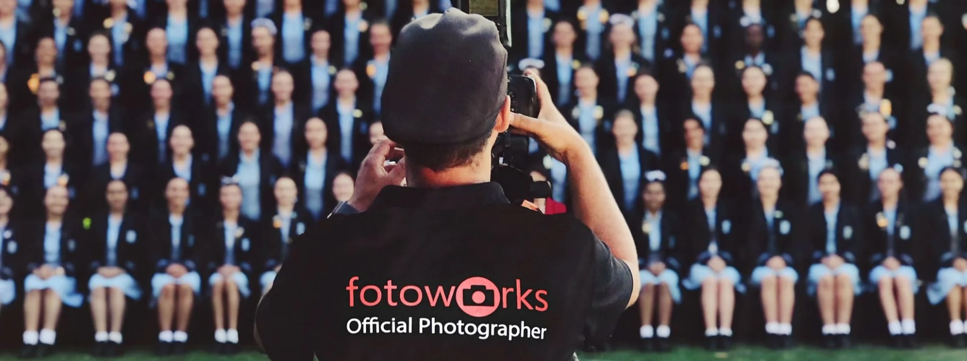

Ordering your school photos from Fotoworks Online
If you did not place an order with Fotoworks via the order envelope, you can still order online!
- Once you have your unique access key, visit the Fotoworks website at https://www.fotoworks.com.au/
- Click the “Order Online” tab at the top right corner of the home page
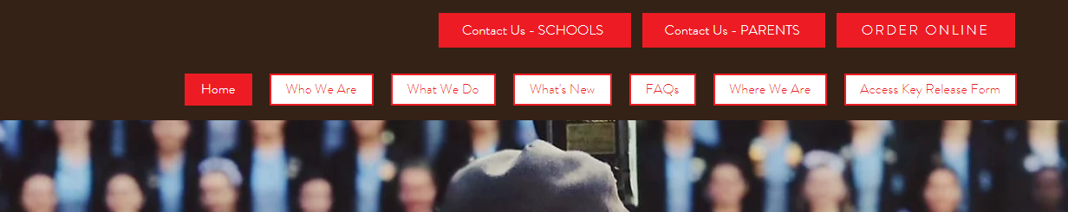

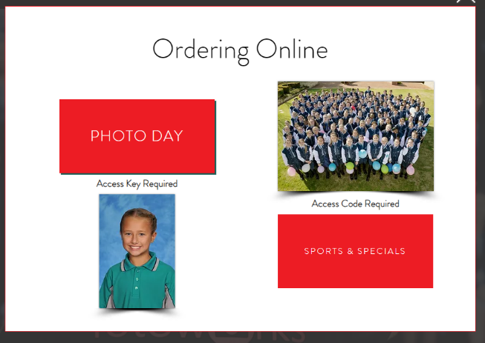
- Then click “Photo Day” 4. Type in your access code
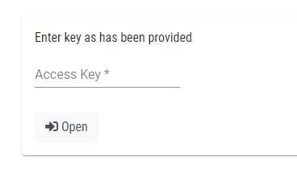

- Select the package you wish to purchase and make payment.

If you have any questions, please email the College at Sevenoaks.SC.Admin@education.wa.edu.au.

